Khoros Award – Rookie of the Year

Company Background
Intel creates world-changing technology that enables global progress and enriches lives. We stand at the brink of several technology inflections—artificial intelligence (AI), 5G network transformation, and the rise of the intelligent edge—that together will shape the future of technology. Silicon and software drive these inflections, and Intel is at the heart of it all. Data has emerged as a transformational force in an era where an explosion of devices permeates all our interactions. Retail stores, hospitals, manufacturing plants, and even automobiles are becoming factories of data. That data must be moved, stored, and processed faster and more securely than ever before. We are unleashing the potential of data to unlock value for people, business, and society on a global scale.
- Describe your company and your organization.
Intel has transformed from a CPU manufacturer to a global manufacturer of hardware and software that enables new technologies, such as Artificial Intelligence and 5G Networks. The Intel Support Community is supported out of the Customer Experience and Scale team.
- Why did you choose to invest in Khoros and what was your experience before making the switch from a previous solution or investing in new technology.
2 years earlier we evaluated different community platforms and selected Khoros, which had more features and could support our 75 forums. But our IT group thought we could use an alternative option that was less expensive but much more basic.

Our experience on that platform, before migrating to Khoros, was that customers were complaining about the platform. They didn’t like the Boards showing only 6 threads before you had to click Show More to see more threads, there were no breadcrumbs, they couldn’t post or reply to threads on mobile devices, they couldn’t ‘follow’ a thread unless they replied to it. The default filter was to surface threads with the highest number of replies, which revealed old threads discussing significant issues, something customers weren’t really interested in seeing and we were embarrassed to show. There was no spam management, and only a very basic gamification tool.

An analysis of customer verbatims showed that the problem wasn’t the response time or professionalism of our agents, it was the platform itself, customers did not like using it. See graphic below:

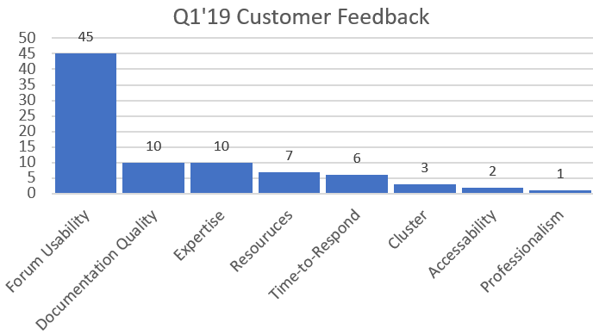

Internally, we also had problems. Reports from the that platform were very basic and did not offer any insights. The case management integration with our alternate supplier was poor and did not provide rich data. Painfully, our Customer Effort Satisfaction scores immediately dropped over 10 points after implementing the alternate platform, from 71% down to ~ 60%, and stayed this way until we implemented Khoros in Q2’20. See graphic below:

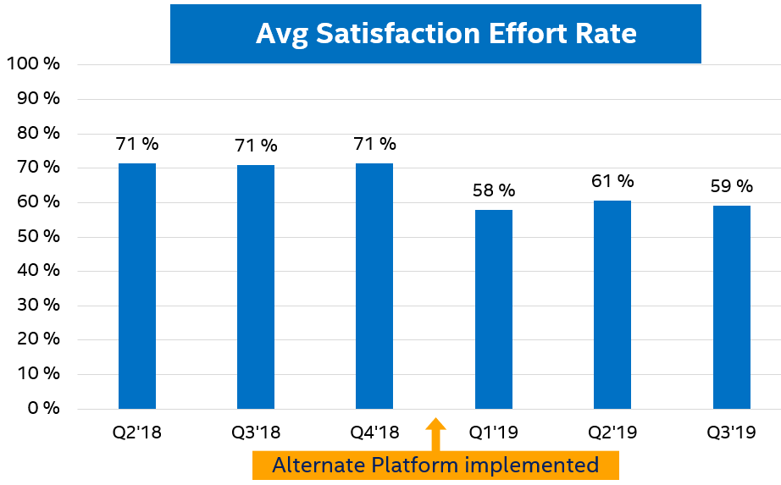

We decided to invest in Khoros because it offered us the ability to consolidate all of our separate communities onto one platform, which our previous platform could not support. The Khoros platform is robust enough to handle a large enterprise customer. With over 75 forums, we needed a way to surface the forums to customers in a way they could easily find the content they’re looking for, that made it easy for customers as well as agents to use. We also needed great community analytics so we could obtain insights from all the customer feedback we were receiving and take action to improve our business.

Our goal is not to deflect customer inquiries but to support them and improve our products so they will come back for more. We feel we have a partnership with Khoros to do this. They provide BKMs from other customer findings and are continuously improving the platform which gives us a competitive edge in supporting our customers.

- What were your goals when investing in Khoros technology and what successes have you already experienced because of the investment? Please include metrics, if possible.

- Our first goal was to consolidate our 2 separate community platforms into one. Our previous platform was not able to support 75 forums but by moving to Khoros we could provide One Intel Community Support solution for customers by consolidating our 40 software forums onto the same platform with our 35 hardware forums. We liked the ability to have flexibility in surfacing the content right out of the box. There was no ‘customization’ required.

Initial results have been outstanding. See graphic below:
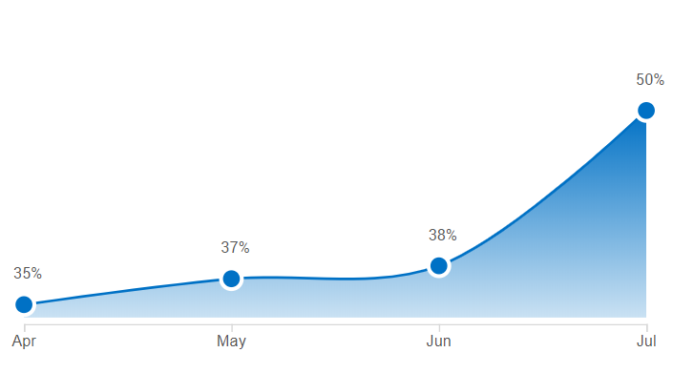
N=131
Could you Find What You Were Looking For?

- Our second goal was to improve our Customer Satisfaction Scores back to 71% if not higher. By having a platform that supported mobile device users, encouraged peer-to-peer support, had robust spam management, and great analytics, we knew it would be a better experience for our customers, and therefore yield higher Satisfaction Effort scores. We were excited to see a 7 point jump in our Customer Satisfaction Effort Scores just using Khoros out-of-the-box. We look forward to improving upon that even more in the upcoming months. See graphic below:
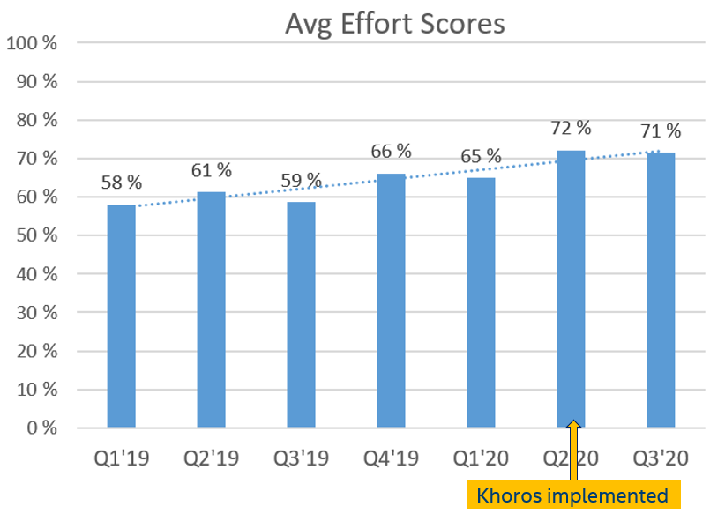
- Our third goal was to have better analytics. Our previous platform had basic analytics such as how many members were joining, who was flagging spam. We knew the Khoros platform had more and better features, as well as analytics that would give us better insights to support customers. Now with Top Content, for example, we can zero in on rising issues before they get worse. We love how we can create a report on top issues for the week and have it automatically emailed weekly to my support engineers. It makes it easier and faster for us to improve products for our customers.

Here’s an example of a “Top Content” Report from Khoros Community Analytics that our support engineers appreciate receiving regularly. It shows the title of the thread, the URL so you can locate it, when it was published, and how many views and replies it is receiving. This helps us quickly identify trends that we may need to address. Graphic below:

Topics | URL | Publish Date | Page Views | Replies
Possible problem with UHD 630 | https://community.intel.com/t5/Graphics/Possible-problem-with-UHD-630/m-p/1189830#M88150 | 7/6/2020 | 295 | 24
driver for display | https://community.intel.com/t5/Graphics/driver-for-display/m-p/1186871#M87892 | 6/25/2020 | 212 | 20
6 - bit depth on Intel UHD Graphics 620 | https://community.intel.com/t5/Graphics/6-bit-depth-on-Intel-UHD-Graphics-620/m-p/1191002#M88230 | 7/9/2020 | 122 | 12

Our customers have been providing great feedback:
- Smartphone support *vastly* improved. (To put the Smartphone happiness into context, with the previous platform, we had over 700k mobile views/month but users couldn’t easily post questions or replies. It just didn’t work. Now it does)
- Much improved layout.
- Much improved visibility. (they like how most recent questions are surfaced for easy visibility)
- Message drafts being saved is a great feature – and has saved my bacon a couple of times already (especially when accidently close browser tab).
- Much improved editor. Better support for handling (multiple!) attachments. Better tool bar, it includes an attach button!
- Love, love, love that I can get notifications for every post. This allows me to use email program more effectively and make sure I don’t miss anything.
- Like little popup notifications of people posting, etc.
- Like Notification Feed and icons indicating where answer accepted, kudo given, mentioned, etc.

This feedback makes us very grateful because if we have happy Super Users, they will stay and play in our forums, supporting customers off-hours and on weekends and holidays. For us, this is the ultimate success, when our customers are happy with our support, and we’ve got the feedback to continuously improve our product offerings. We are very pleased with our partnership with Khoros.

