SANE Australia Khoros Kudos Awards submission

SANE Australia is a national mental health charity making a real difference in the lives of people affected by complex mental health issues through support, research and advocacy. Guided by our vision and mission, values and behaviours, we help people live long and fulfilling lives, free from stigma and discrimination.

SANE Australia supports anyone affected by complex mental health issues, including family and friends, through a range of free services including opportunities for peer connection and learning through supportive peer groups and our anonymous online forum community.

We have worked in partnership with Khoros for some time to assist with our key priorities around community support, peer to peer support and community moderation. However, our use cases expanded during a time when a particular subset of Australians required our services.

During the summer of 2019 to 2020, prior to the challenges of COVID-19, Australia experienced the most catastrophic bushfire season in the country’s history. Millions of hectares of land were burnt, 33 lives lost and over 3000 homes destroyed. The impacts of this disaster continue to be felt by those Australians impacted.

To support the thousands of Australians impacted by the fires, we delivered a bespoke area of our community focused on connecting people who were affected by the fires, to connect with others and support their recovery. In response to the severe emotional toll the event had taken, SANE Australia established Life After Bushfires to support people with complex mental health issues (CMHI) who were affected by the devastating bushfires. The initiative was created in our existing Khoros Community as its own unique forum.

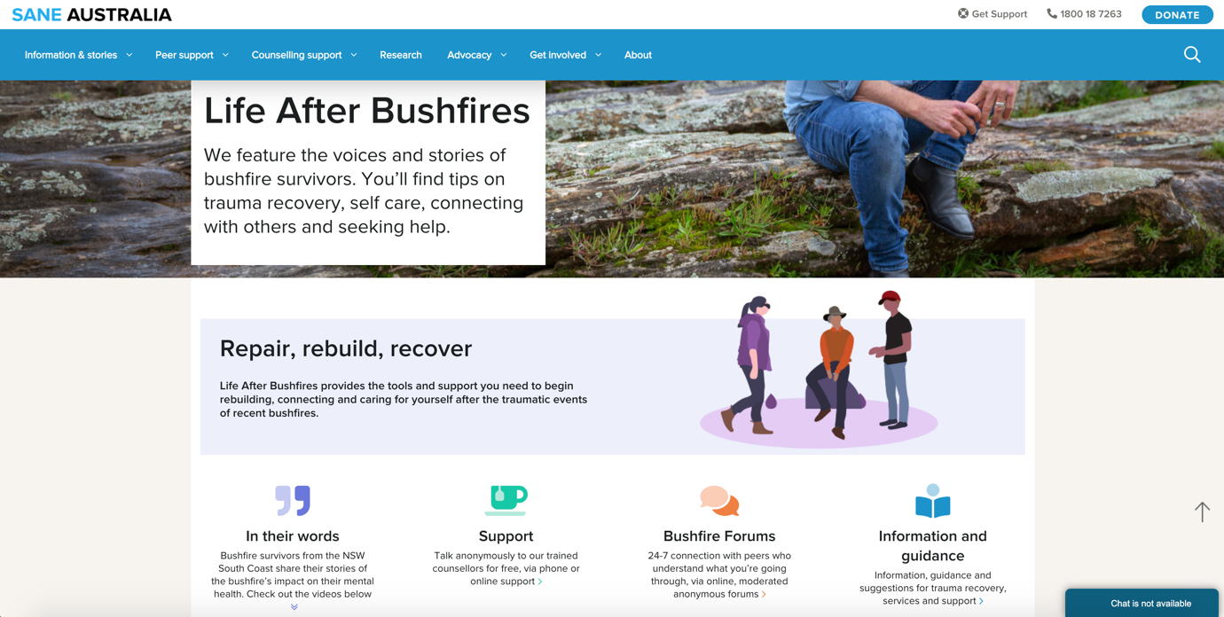

Life After Bushfires provides tailored information, services and connection that supports affected peoples’ ability to emotionally repair and ultimately, recover. Our approach to developing this resource was to conduct formative research to identify which of our existing offerings were able to deliver on what the evidence base was telling us. We then built those components, in consultation with the community, to develop a resource that was aligned with the needs of people with CMHI in communities most heavily impacted by the fires.

The goal of Life After Bushfires is to ensure that people with CMHI who have been affected by the bushfires are assisted with tailored information, services and connection that support their recovery.

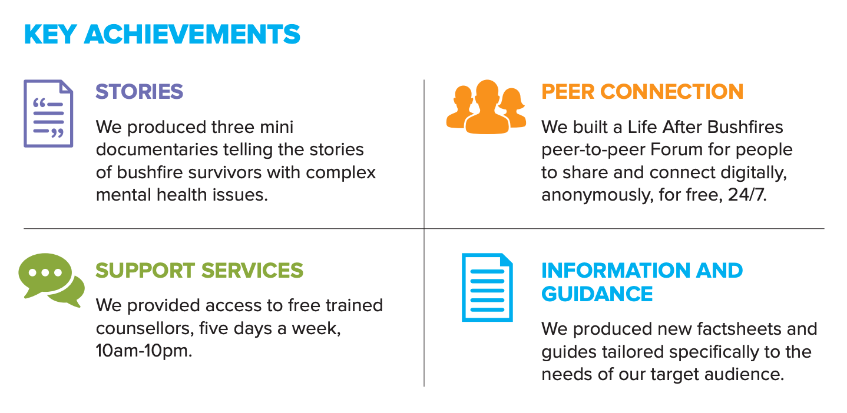

This project was developed to provide very targeted, nuanced support for those with complex mental health needs in bushfire affected areas and has achieved so much to be proud of. The qualitative and quantitative evaluation shows that overall Life After Bushfires has delivered positive outcomes for service users. For example, the 30,000 people that watched the mini documentaries on social media. To contextualise this figure, there are 177,007 people living in the three local government areas (LGAs) in southern NSW that we targeted our support. SANE predicts that approximately 3% of the population are living with a CMHI at any given time, and for every one person with a CMHI there are 5 family members/friends/colleagues/carers that are directly impacted. Applying this logic to the 177,007 people living in the targeted LGAs we can hypothesise that there are approximately 26,550 people affected by CMHIs - meaning that according to the view numbers, our content more than reached this vulnerable group.
Over its first 4 months:

- 30k people viewed our mini - documentary videos on social media
- 5,600 people visited the Life After Bushfires website
- 4k people have connected on the Life After Bushfires peer-to-peer Forum
- 200 people participated in the online Topic Tuesday Forum event
- People spent an average of 15 minutes per session on the online peer Forums

The secondary benefit to arise from this project was SANE’s ability to learn. This project was designed as a pilot, to test and learn how we, at SANE, can provide support for members of our community affected by disasters. We have taken a broad range of learnings from this project across a vast range of areas including community consultation, research, co-design, promotion and service delivery. We are already looking to bring Life After Bushfires into SANE’s main service offerings by evolving it into a broader disaster-related area of our online community.

Life After Bushfires, made possible by Khoros, has been a great success, and we are confident that people in the most heavily bushfire affected parts of Australia with complex mental health issues have received the information, support and connection that they need to aid their recovery.

